# Theoretical Background

An important component of the hydrologic cycle is the stream water – groundwater (SW-GW) interaction. There are three basic types of interaction (Figure 1). When the stream is connected to the groundwater, depending on the water table elevation with respect to stream elevation, the water can flow from the stream to groundwater (losing stream) or vice versa (gaining stream). The third type occurs when the stream is disconnected from the water table and an unsaturated zone exist between the riverbed and the water table.

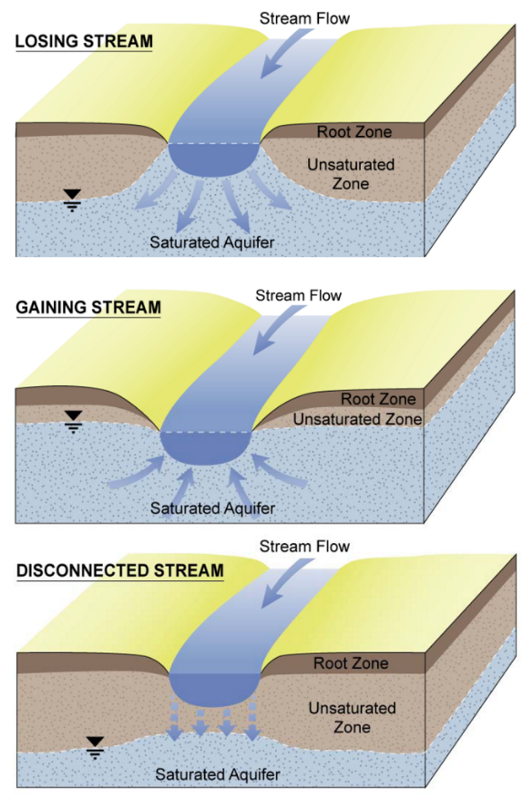

Figure Stream groundwater interaction types

The focus of this report is primarily on the simulation of the two connected interaction types. Figure 2 shows a highly detailed simulation of the flow field between a river (blue rectangle) and groundwater. The flow is shown as many streamlines. First, we observe that the flow becomes horizontal after a “*far-enough*” distance away from the river where the equipotential lines (streamlines) become parallel. Therefore, in the vicinity of the river the Dupuit-Forchheimer assumption does not hold. Hence to simulate accurately the stream groundwater interaction one would need to use a detailed mesh with sufficiently small horizontal and vertical discretization. However, this would result in a time-consuming simulation model.

Figure View of seepage from the river to the aquifer in a vertical cross-section

In general, the horizontal spatial extended of the river footprint (the area where the flow is not horizontal) is relatively small compared to the spatial extend of a typical groundwater basin therefore the stream groundwater interaction is commonly approximated using a simpler approach.

The streamlines of Figure 2 highlight that the resistance to flow is quite different around the wetted perimeter of the river. The top ones that originate from the sides of the river are almost linear denoting small resistance to flow, while the ones that originate from the bottom center of the riverbed follow a more complicated path with significant curvature denoting a significant resistance until they become horizontal. To simplify the computations, we can replace the individual streamline conductances (inverse of resistance) with a composite conductance. In this report the composite conductance is denoted as $Γ$. Using the notion of conductance, we define the seepage as:

|  |  |  |
| --- | --- | --- |
|  |  | () |

where is the length if the river, $K_{H}$ is the horizontal hydraulic conductivity, $h_{S}$ is the stream head and $h_{f}$ is the groundwater head at some distance where the flow is horizontal. Equation (1) is known as Steam-Aquifer Flow Exchange (SAFE) method.

Notice that equation (1) is also equivalent to the equation that is used by Modflow and the stream packages 4.1 4.2 of IWFM:

|  |  |  |
| --- | --- | --- |
|  |  | () |

where is the hydraulic conductivity of the streambed and $e_{cl}$ is the thickness of the streambed.

We can see that in both formulas the difference between groundwater and steam head is multiplied by a coefficient $C_{SAFE}=2L_{R}ΓK_{H}$ and $C_{RP}=\frac{K_{cl}}{e_{cl}}L_{R}W_{PER}$ (RP stands for River Package as this is the formula that is being used by Modflow river package).

In the following chapter we present the steps to calculate SW-GW using the SAFE formulation.

# Implementation of SAFE approach

According to equation (1) the calculation of the seepage discharge depends on the conductance $Γ$ and the head difference between stream and groundwater head. The length $L_{R}$ and hydraulic conductivity $K_{H}$ are constant user defined inputs.

## Conductance $Γ$ calculation

The original SAFE formulation was developed for finite difference method where the estimation of the “*far-enough*” distance and the groundwater head at that distance is straightforward. To adapt the SAFE formulation for finite element method where the elements can be either triangular or irregular quadrilaterals an additional modification is needed. Figure 3 shows the two river segments that are joined at node 2 and all the element associated with the node 2. According to SAFE formulation, the flow exchange is calculated at each node by considering the area of influence of the nodes. In Figure 3 the area of influence is highlighted with green dashed lines. The areas of influence are used in several procedures of the IWFM code therefore they are calculated once at the begin of the simulation. To calculate the “far enough distance” SAFE expects that the areas of influence are of rectangular shape. To this end, the actual shapes of areas of influences are replaced by equivalent rectangular shapes where one side is equal to the half of stream segment and the other side is set so that the area is preserved.

Figure Definition of area of influence and its equivalent rectangular area

The calculation of seepage between stream and groundwater is carried out at the mesh element nodes. Therefore, in practice the code calculates one “far enough distance” for each node as $G_{SAFE}=2A/{\left(L_{F}+L_{B}\right)}$ where $A$ is the area of influence calculated as the sum $A=\sum_{i=1}^{N^{e}}{A_{i}^{e}}$ of the individual element areas of influences $A_{i}^{e}$ and $L_{B},L_{F}$ are the stream segment half lengths before and after the stream node respectively.

The groundwater head $H_{gw}$ and the Stream head $H_{stream}$ for each river node are known from the previous iteration or the initial conditions.

Figure Schematic illustration of the river section

The river stage $H_{stg}$ is calculated as

|  |  |  |
| --- | --- | --- |
|  |  | () |

Where is the elevation of the top of the riverbed.

The river stage is used to calculate the wetted perimeter $W_{p}$ via user defined rating tables, which are functions between $W_{p}$ and $H_{stg}$.

Next the saturated thickness of the aquifer $D_{aq}$ is calculated as the sum of the elevation of the phreatic surface (with datum at the bottom of the user selected geologic layer) plus the thickness of the capillary fringe.

|  |  |  |
| --- | --- | --- |
|  |  | () |

Where is the elevation of the selected geologic layer and $h_{ce}$ represents the thickness of the capillary fringe.

Then the normalized depth $D_{p}^{N}$ and normalized wetted perimeter $W_{p}^{N}$ can be calculated as

|  |  |  |
| --- | --- | --- |
|  |  | () |
|  |  | () |

Based on the normalized depth and wetted perimeter the coefficients $a_{1}$ and $a_{2}$ are estimated from the following table

The flat isotropic conductance $Γ_{iso}$ i.e., the correction for accounting the degree of penetration, is a function of the parameters $κ$ and $Γ_{flat}$ and the coefficients and

|  |  |  |
| --- | --- | --- |
|  |  | () |
|  |  | () |
|  |  | () |

The conductance value obtained by (7) applies only when

* The distance from the riverbank at which the head drops is evaluated exactly twice the aquifer thickness.
* The aquifer is isotropic
* The grid quarter size corresponds exactly to the location of the standard anisotropic far distance
* There is no riverbed clogging layer

In the following steps we refine the conductance estimation by correcting for the above assumptions.

Approximate the equivalent river width using the assumption of the rectangular river cross section:

|  |  |  |
| --- | --- | --- |
|  |  | () |

It should be noted that method is insensitive on the actual shape of the river if the normalized wetted perimeter and degree of penetration are similar.

The river width is used to calculate the parameter

|  |  |  |
| --- | --- | --- |
|  |  | () |

Next SAFE calculates a correction $Γ_{iso_∆}$ for the isotropic conductance $Γ_{iso}$. The correction depends on the anisotropy ratio.

For isotropic aquifers the correction is given by

|  |  |  |
| --- | --- | --- |
|  |  | () |

Where .

For anisotropic aquifers we calculated the following:

|  |  |  |
| --- | --- | --- |
|  |  | () |
|  |  | () |
|  |  | () |
|  |  | () |

Where and $K_{v}$ is the aquifer horizontal and vertical hydraulic conductivity.

Then the correction is calculated by considering the anisotropy as follows:

|  |  |  |
| --- | --- | --- |
|  |  | () |
|  |  | () |
|  |  | () |
|  |  | () |

The last step in the Safe method is to correct the value of $Γ_{iso_Δ }$ or $Γ_{anis-Δ_{G}}$ to account for the presence of the riverbed clogging layer.

For isotropic aquifers the correction is given by

|  |  |  |
| --- | --- | --- |
|  |  | () |

Where is the thickness of the riverbed.

For the anisotropic aquifers the calculation is identical to eq (21) after replacing the $Γ_{iso_Δ }$ with the outcome of eq. (20) $Γ_{anis-Δ_{G}}$.

## Head difference

The head difference in the current implementation of the SAFE method is defined as the difference between the maximum of incipient desaturation $h_{incip}$ or groundwater head $H_{gw}$ and the stream head .

|  |  |  |
| --- | --- | --- |
|  |  | () |

The incipient desaturation is calculated as:

|  |  |  |
| --- | --- | --- |
|  |  | () |

Where is the entry pressure which is a user input that depends on the riverbed material. The incipient desaturation is the average head that will cause the desaturation below the riverbed. Therefore, it can also be used as a criterion when the stream is disconnected. In the current implementation the same formula is used for all cases.

In the other stream packages of IWFM the head difference is calculated by using the maximum of groundwater head $H_{gw}$, and the bottom or the top of the riverbed.

Finally, the seepage discharge is calculated

|  |  |  |
| --- | --- | --- |
|  |  | () |

Where is the river length of the corresponding stream node.

## Calculation of Asymmetric Seepage Discharge

An advantage of the SAFE method is that it can differentiate seepage discharge between the left and the right side of the stream due to the different stresses that may occur. In the following report we refer to this calculation as asymmetric seepage discharge.

The asymmetric seepage discharge is calculated at the end of each time step. Initially, SAFE calculates a representative groundwater head for the left and right side of each stream segment. There are two approaches, i) the interpolation method and ii) the flow-based method. The interpolation calculates the groundwater head by interpolating the groundwater head from the finite element solution while the flow-based approach is based on the flow exchange between elements.

To calculate a representative interpolated head left and right, we offset the river segment a distance equal to $G_{safe}$ left and right and discretized the offset segment. Next we interpolate the head solution at the discreet points and average their values.

Figure Points to calculate the average interpolated head left and right

For the flow-based approach the left and right representative groundwater head is given by the following equations

|  |  |  |
| --- | --- | --- |
|  |  | () |
|  |  | () |

Where is the effective porosity, $A_{L}$ and $A_{R}$ are the area of influence of the stream nodes left and right of the stream $Q_{L}$, $Q_{R}$ is the net of water volume that flows in and out of the left and right element respectively and $W_{L},W_{R}$ are the area weights of the nodes calculated as $W_{L}= {A_{L}}/{\left(A_{L}+A_{R}\right)}$ and $W_{R}= {A_{R}}/{\left(A_{L}+A_{R}\right)}$ respectively.

The equations 1 to 6 are identical in the asymmetric calculations. However, we differentiate the $Γ_{flat}$ for left and right as:

|  |  |  |
| --- | --- | --- |
|  |  | () |
|  |  | () |

Using the left and right $Γ_{flat}$ we calculate different values for the

|  |  |  |
| --- | --- | --- |
|  |  | () |
|  |  | () |

Next, we apply the corrections as in the symmetric case for either side of the river. The correction for the isotropic conductance in case of isotropic aquifers is modified for left and right as:

|  |  |  |
| --- | --- | --- |
|  |  | () |
|  |  | () |
|  |  | () |
|  |  | () |

The correction for the clogging layer for the isotropic case is calculated as follows

|  |  |  |
| --- | --- | --- |
|  |  | () |
|  |  | () |

For the anisotropic aquifers we calculate $ρ_{f}$ using the equations 11-14 and then we apply the two corrections for the isotropic conductance and clogging layer.

|  |  |  |
| --- | --- | --- |
|  |  | () |
|  |  | () |
|  |  | () |
|  |  | () |
|  |  | () |
|  |  | () |
|  |  | () |
|  |  | () |
|  |  | () |
|  |  | () |

Last the seepage discharge for the left and right side of the stream is calculated separately as

|  |  |  |
| --- | --- | --- |
|  |  | () |
|  |  | () |

The flow-based method is mass conservative, therefore ${Q_{sint}}_{L}+{Q_{sint}}_{R}$ is always equal to $Q_{sint}$ (eq. 24).

However, when the left and right heads are calculated by interpolation the ${Q_{sint}}_{L}+{Q_{sint}}_{R}$ is not equal to $Q_{sint}$ (eq. 24). To convert the interpolated head method to mass conservative after the calculation of ${Q_{sint}}_{L}$ and ${Q_{sint}}_{R}$ the amounts are rescaled so that their sum is equal to $Q_{sint}$ (eq. 24) as $Q_{{sint}_{L}}^{m}=Q_{sint}\frac{{Q_{sint}}_{L}}{{Q_{sint}}_{L}+{Q_{sint}}_{R}}$ and $Q_{{sint}_{R}}^{m}=Q_{sint}\frac{{Q_{sint}}_{R}}{{Q_{sint}}_{L}+{Q_{sint}}_{R}}$.

## Algorithm to identify left and right elements

To calculate the left and right heads using the mass balance approach we need to identify which elements are left and right of the stream.

In IWFM there are three types of relations between streams reaches and elements (Figure 5). The first type A corresponds to the case where the stream segment coincides with the sides of the mesh elements. The second type B considers elements where only a single element node coincides with a stream node, while the third type C is the case where the stream segments runs diagonally the mesh element.

Figure Relations between stream segments and mesh elements

Initially, the algorithm identifies the left and right elements of the first type. IWFM code provides functions to query the elements that lay on either side between any two nodes that are connected in the element mesh. However, the code does not report which element is left and right. To do so we calculate the cross product of vectors $\hat{AB}$ and $\hat{AC}$ (Figure 6) where vector $\hat{AB}$ coincides with the stream segment oriented so that point $A$ is the upstream node of the stream segment and point $B$ is the downstream node. Point $C$ is the barycenter of the one of the elements. The direction of the cross product of the two vectors identifies whether the element that contains point $C$ is left or right of the stream segment.

Figure Vector definition for the left and right identification of the elements

If the stream segment does not coincide with any side of the element mesh (e.g. type C), then the IWFM query for the left and right elements will return NULL. In that case the code identifies the id of the element that the stream run diagonally and calculates the left and right area of influence.

The elements of type B are identified in a second iteration. During this iteration, for each stream node except the first and last, we query all the elements that touch the stream node in question. If any element of the list has not been identified in the previous iteration as type A or C then this element is definitely of type B and the area of influence of that node from the element is added to the previously calculated area. In this second iteration we do not consider the end points of the stream reaches. Therefore, the area of influence for those nodes consists of the elements on either side of the stream only (Figure 7). We can that under certain element geometries this can lead to under or over estimation of the area of influence.

Figure Area of influence at the end point of a stream

# Applications

## Hypothetical test case

The SAFE method was applied to a simple hypothetical example. The domain is a rectangular area with dimensions 2,500 m and 1,250 m along the x and y axis respectively. The top and bottom boundaries are considered impervious, while the left and right sides are assigned a constant head boundary condition which sets a groundwater flow from right to left. Horizontally, the domain is discretized into 16 columns and 8 rows. Vertically the domain is discretized into three layers with different hydraulic properties that are shown in Figure 8 (right).

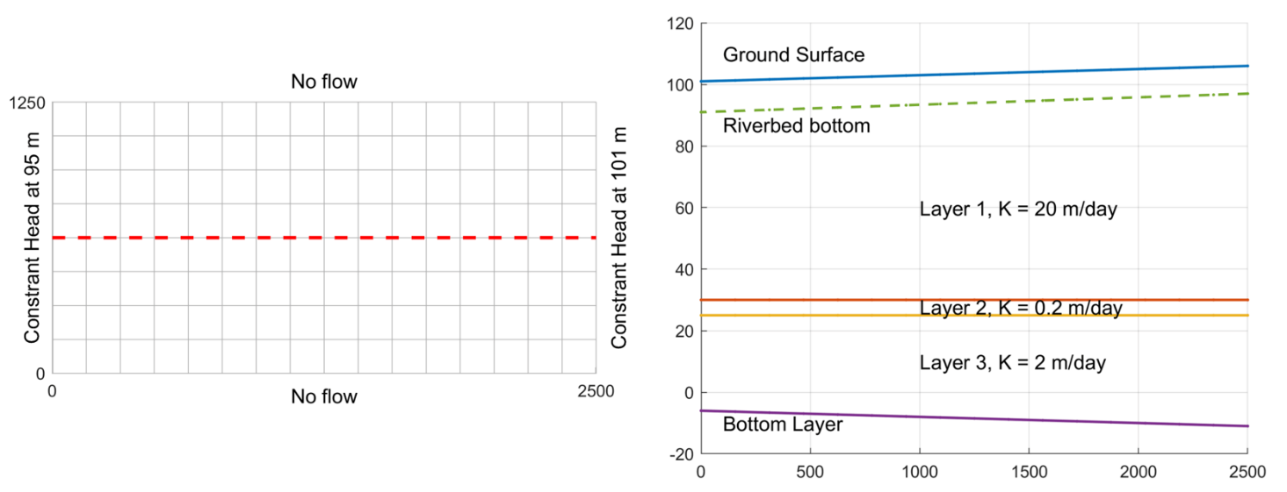

Figure Left) Hypothetical domain and discretization. Right) Cross section view.

Along the center of the aquifer at y = 625 m there is a stream (Figure 8 left red dashed line) with a specified inflow at the inlet at x=2500 m. The riverbed bottom is set 10 m below the ground surface elevation. This setup, along with the boundary conditions, ensures that the stream is always connected to the aquifer as a gaining stream. The riverbed material is assumed to be silty-loam with hydraulic conductivity $K_{cs}=0.3168 m/day$ and entry pressure $h_{ce}=50.87 cm$ (Appendix 1). The thickness of the riverbed is set to $e_{cs}=1 m$. For each stream node we defined a rating table that is used to calculate the flow rate and the wetted perimeter as a function of the stream stage. In this example all the stream nodes use the same rating table (Figure 9)

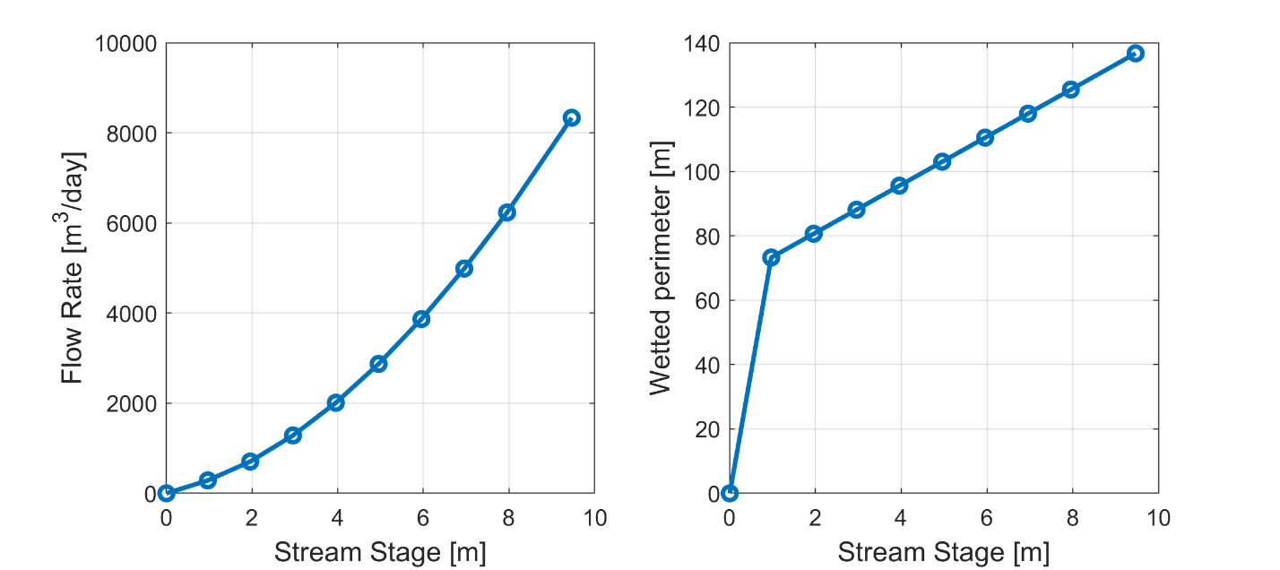

Figure Stream node rating tables

The test case was simulated using the stream package 4.1 of IWFM and the SAFE method. In SAFE method the calculation of the saturated thickness of the aquifer $D_{aq}$ depends on a user defined layer (4) which does not necessarily coincide with the bottom of the aquifer. In this example we run the model 3 times to test the sensitivity of the results by setting ${ELEV}_{bot}$ the equal to the elevation of the 1st, 2nd layer and bottom of the aquifer. The results are compared against the IWFM 4.1 solution. Figure 10 shows the groundwater head of the first layer, which also coincides with the water table. Due to the constant head boundaries the head drops from 101 m to 95 m. Along the river the groundwater head dips by an additional ~0.5 meter due to SW-GW interaction.

Figure Groundwater head of the first layer. The red line highlights the river where the hydraulic head drops

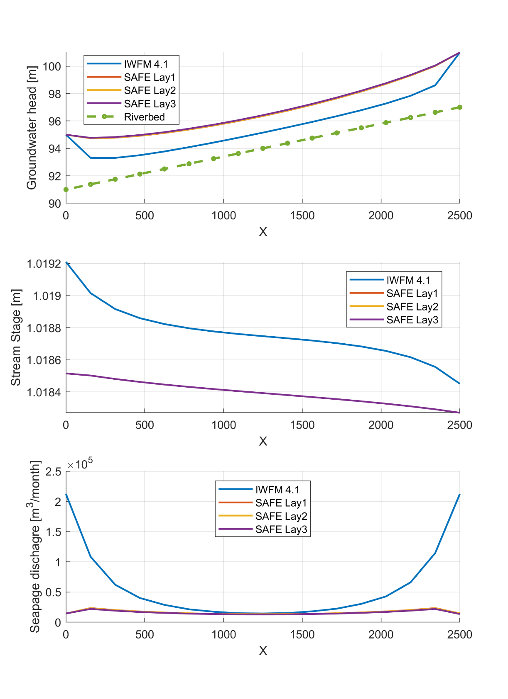

Figure Comparison between IWFM 4.1 and SAFE using three different geological layers to define the aquifer depth below stream

The groundwater head, stream stage and the seepage discharge in this example appear relatively insensitive to the choice of the elevation of the geologic layer below the stream. We have found that when choosing deeper layers, the groundwater head is estimated slightly higher and the seepage discharge slightly lower. Yet the differences can be considered rather negligible.

The IWFM and SAFE solutions are considerably different. The groundwater head for IWFM is lower than the SAFE solution by 1.5 meters approximately except the nodes where the groundwater head was imposed by the constant head boundary conditions (Figure 11 top panel). The stream stage calculations of IWFM and SAFE (Figure 11 middle panel) while appear different due to the y scaling, their actual difference is approximately 0.05%. On the other hand, the seepage discharge is quite different between the two models (Figure 11 bottom panel). Near the boundaries of the aquifer where the constant head boundary was imposed the seepage discharge (SPD) difference becomes larger, while very close to the center the two model predictions almost coincide.

To investigate this further, we examine the two terms that are used in the seepage discharge calculation i.e. $C_{RP}$ or $C_{SAFE}$ and the $H_{diff}$. The head difference depends on the stream head and the groundwater head. The stream head is almost identical in both models (Figure 11 middle panel) therefore the head difference is different between the two models due to the groundwater head. Overall, the head difference predicted by SAFE is higher compared to the IWFM. For example, at the center of the domain x = 1250 m the head difference between stream and groundwater head is -0.13 m and 1.4 m for IWFM and SAFE respectively.

Figure Groundwater head of the first layer.

The second term of the SPD is the conductance. In IWFM formula the only variable that can change during the simulation is the wetter perimeter. The wetter perimeter is function of the stream stage which varies between 1.085 and 1.0195 along the stream therefore is practically identical for all nodes and equal to 73.64 m. The ratio ${K_{cl}}/{e_{cl}}$ is also constant for all nodes hence the difference in the two end nodes of the river is due to the stream length associated with each node. The stream length for the two end points is half the element size 78.125 m while for the remaining nodes is equal to the element size 156.25 m. In this example the node that is less influenced by the imposed boundary conditions is the center node with x = 1250. Interestingly the SPD estimation of both models is very similar and equal to 14,540 ${m^{3}}/{month}$. Thus, we observe that the model modified the groundwater head and conductance value so that the final discharge values are of the same order. The difference in conductance between the end nodes and the remaining nodes would be reduced by using a finer grid.

### Asymmetric seepage discharge

An advantage of the SAFE approach is that it can differentiate between the left and right SPD. For the calculation of asymmetric SPD SAFE calculates a representative left and right head. There are two ways to calculate the head. One is based on the element flows left and right and the other using interpolated head from the finite element solution. Figure 13 shows the seepage discharge and how it was split left and right. The example is perfectly symmetric therefore the SPD is split in half for both cases. However, when the calculation of the head is based on mass the sum of the left and right SPD estimations are equal to the total sum of the SPD. On the other hand, when the left and right heads are extracted by the interpolated solution we observe that the sum of left and right SPD is slightly higher than the total symmetric SPD. The results of Figure 14 (right) shows the unmodified and .

Figure Asymmetric seepage discharge using based on flow based head and interpolated head

To introduce asymmetric conditions in this example we added four pumping wells at the right side of the stream (Figure 14).

Figure Wells location for hypothetical example

The SPD left and right side of the stream when the four wells are introduced are show in Figure 15. When we use the flow based calculated head the SAFE is able to differentiate the SPD left and right. However when we use the interpolated heads the difference of SPD between left and right is negligible. (The results of Figure 16 are based on the unmodified SPD terms). The reason is that the hypothetical example is a perfectly symmetic example with respect to the stream therefore the pumping is not so large to affect the symmetry to such a degree where the heads left and right are noticeably different.

Figure SPD left and right for asymmetric conditions

To disturb the symmetry of groundwater head, we modified the constant head boundary conditions so that the heads they vary linearly along the y axis (Figure 16). For the left boundary, the head varies from 95 m (at y = 0) to 100 m (at y = 1250) while for the right boundary the head varies in the opposite way from 101 m (at y = 1250) to 106 (at y = 0). The four wells of the previous run (Figure 14) are present in this modified run. The aquifer was simulated with SAFE method and the asymmetric SPD was calculated based on the two asymmetric head methods i.e i) flow- based head, ii) interpolated head.

Figure Hypothetical example with modified boundary conditions and well pumping adjacent to the stream

The groundwater head of the top layer for the modified constant head boundary conditions is shown in Figure 17. The modified boundaries force the solution to impose variable asymmetric conditions along the stream.

Figure Groundwater head of the top layer for the modified boundary conditions

When the asymmetric heads are calculated based on the element flows then they are not influenced by the regional flow. We observed that the left and right distribution of SPD in the modified example (Figure 18) is very similar to the original (Figure 15). The SPD is differentiated only at the stream nodes associated with the elements where the pumping occurs. In the remaining stream nodes, the SPD is distributed equally left and right on the stream. On the other hand, the SPD based on the interpolated head for the modified example shows that considers the strong regional hydrologic conditions. For the first half of the stream the SPD at the right side is higher compared to the left side. The difference between the two sides fades out and become zero at the center of the domain and the pattern is reversed at the second half of the stream. Similarly, to the original example the SPD based on interpolated heads appears to ignore the pumping. In practice the influence of pumping is very small compared to the regional flow.

Figure SPD left and right for asymmetric conditions for the modified example

The results of Figure 19 (right) are based on the unmodified SPD calculations. The SPD using the modified (scaled) SPD so that the mass balance is preserved is shown in Figure 20.

Figure Asymmetric SPD using the modified interpolated calculation

Next, we further modified the previous example by shifting the well locations one row away from the river. Figure 21 shows the results of the simulation. The terms $Qsint$ terms with superscripts H correspond to the interpolation-based method and the terms with superscripts Q to the flow-based method of asymmetric SPD. We observe that the flow-based method fails to capture the flow dynamics from the pumping because equations 25, 26 calculate the asymmetric head based on the flows of the elements that are adjacent to the stream. On the other hand, the interpolation-based method is able to differentiate the SPD left and right but the estimations are driven primarily form the regional flow.

Figure Hypothetical example with modified boundary conditions and well pumping one element apart from the stream

Last we repeated the simulation using significantly higher pumping that in the previous case. Note that the SPD left and right at the center of the stream (x = 1250) is noticeable. On the other hand, the flow-based method (not show here) is not influenced by the large pumping values.

Figure Left) Asymmetric SPD for the modified example of Figure 21. Right) Simulation results with high pumping.

## Central Valley – Coarse grid

In this section we applied the Safe method to the coarse grid version of the C2VSim Central Valley model. The original model uses the stream package 4.2 which uses a constant wetted perimeter for each stream node. For the safe method we supply a function in the form of rating tables where the wetted perimeter is related to the stream stage with the formula $W_{per}= W_{riv}+2{H_{stg}}/{cos⁡(60)}$. The river stage values were obtained from the rating tables of the 4.2 stream package input files, while the river width $W_{riv}$ was estimated using an empirical formula (Figure 10) that relates the river width to the total cumulative stream flow. The total cumulative stream flow values were obtained from original simulation run. The above equation assumes that the river cross section is trapezoid with 60 degrees angle.

Figure Stream width as function of total cumulative volume

The model was simulated for comparison using the stream package 4.2. In the following paragraphs we will explore the differences between the two approaches. It should be noted that the two approaches do not differ only in the way the seepage discharge is calculated but they also use different riverbed conductance values. Typically, the riverbed conductance is a calibrated parameter. However, the Safe approach assumes knowledge of the riverbed material and the riverbed conductance is directly associated with the actual material. Due to the lack of knowledge of the riverbed material we set a uniform sandy loam material with conductance value equal to $K_{cl}=2.03937 ft/month$ and entry pressure $h_{ce}=0.991 ft$. In both simulations the riverbed thickness was set to $e_{cl}=1 ft$. The calibrated riverbed conductances of the original C2VSim model are generally lower that the values of the sandy loam material (Figure 24). It should be noted also that the original model includes several river nodes with 0 conductance.

Figure Histogram of riverbed conductance values of the original C2VSim model.

### Seepage Discharge

The primary variable of interest in this report is the seepage discharge. The cumulative seepage discharge (SPD) across the entire Central Valley exhibits higher variability using the stream package 4.2 compared to SAFE method (Figure 12). We can also see that there is a noticeable discrepancy (~0.5 MAF) between SPD calculated by SAFE and IWFM. However, if we exclude five river nodes with IRV 516-520 (part of sacramento river), the agreement between the two is significantly improved (Figure 13 left). The cumulative seepage discharge for the Sacramento river nodes 516-520 using the stream package 4.2 is 5 orders of magnitude higher than Safe.

Figure Cumulative seepage discharge across the Central Valley

Figure Left) Cumulative seepage discharge across the Central Valley excluding the river nodes 516-520 of the Sacramento river. Right) Cumulative seepage discharge of the Sacramento river nodes 516-520.

Next, we analyze the differences between the two methods for the last time step. In total, the model has 663 stream nodes. For the following analysis we grouped the stream nodes according to the relative values of groundwater and stream head according to the Safe solution. There are in total 284 stream nodes where the groundwater head is higher than the stream head. Their location is shown in Figure 27. These are located mostly on the northern part of CV, on the northern part of San Joaquin River, and along Tuolumne and Merced rivers and Friant-Kern Canal. The calculated groundwater heads are generally slightly higher with a mean difference between the two approaches of 20 ft. Yet there are a few stream nodes where the head differences are as high as 100 ft. The stream head on the other hand is very similar for the two methods. Around 90 % of the nodes have a stream head difference less than 1 ft. Overall, the stream head is slightly higher using the Safe method. The SPD for Safe method is mostly positive indicating that the streams are in gaining state. On the other hand, the SPD for the IWFM is quite variable and certain stream nodes exhibiting extremely either positive or negative large values.

The last group of nodes are those where the stream is disconnected from the groundwater. Note that the grouping is based on the comparison between groundwater head and incipient desaturation. This comparison applies only to the Safe method. For the last time step there are 257 nodes where the stream head and the incipient desaturation are higher than the groundwater head. For stream package 4.2 a stream node is considered disconnected from the stream when the groundwater is lower than the elevation of the riverbed. The number of nodes that is considered disconnected based on IWFM is 377. The disconnected stream nodes are located in the southern part of CV. The groundwater head follows a similar pattern to the second group. The SAFE heads are generally lower with a few nodes exhibiting very large differences. The stream stage are almost identical, while the SPD follow very similar pattern

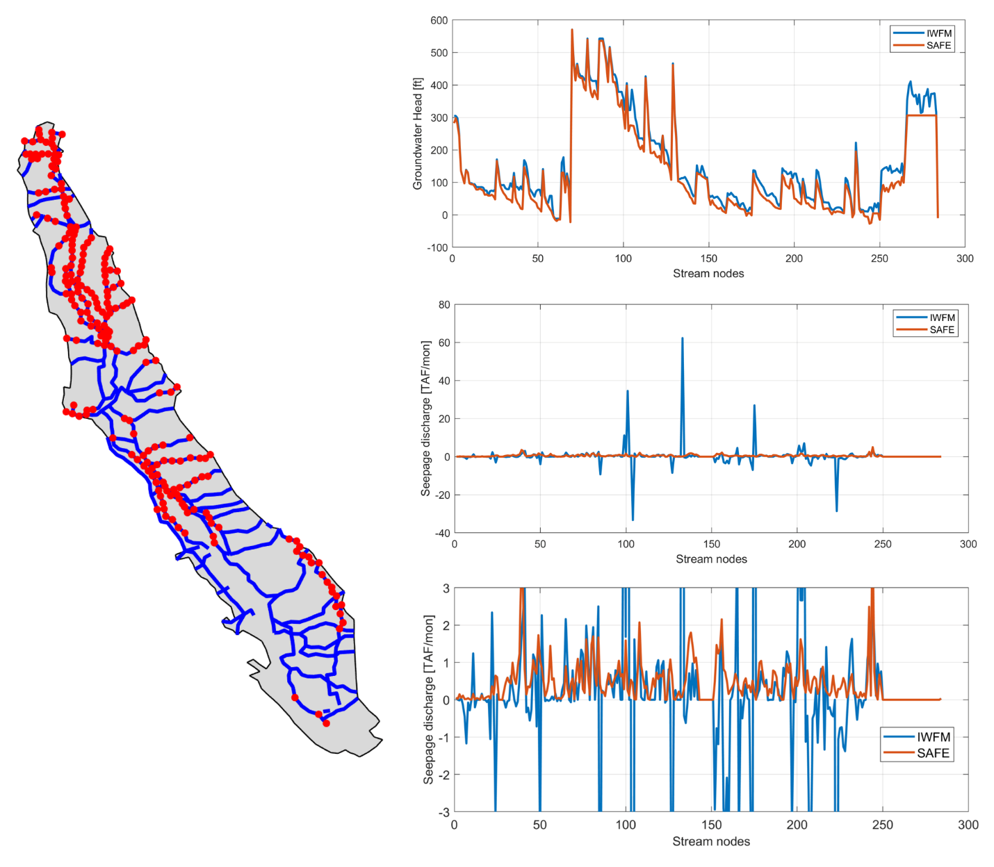

Figure Gaining Stream nodes.

The second group of stream nodes include the nodes that the stream head is higher than the groundwater head while the groundwater head is higher than the incipient desaturation. For those nodes the stream is in a loosing state but connected to the groundwater. The total number of nodes for this group is 122 and they are located around the Delta area and a few stream nodes are scattered across the southern part of CV. For this group of stream nodes the groundwater head using the Safe method is mostly lower than the head of the stream package 4.2. For some nodes (e.g., 15-25) the Safe head is 100-200 ft lower compared to the IWFM method. The stream head for both methods is very similar to the previous group where the majority of the river nodes (i.e.90%) have a stream stage difference less than 1 ft. The SPD for those nodes is negative as the stream is in loosing condition. The majority of the stream nodes have similar order of SPD for the two methods except the nodes 81, 91-94 where the SPD of the IWFM is considerably high.

The mean yearly SPD values in both methods exhibit similar trends (Figure 15 top). In both methods there is a declining trend from 1984 to 1995 which is reversed up to 1999, followed by a continuous decline until the end of the simulation. Overall, the mean value for the Safe method appears higher than the original IWFM 4.2 method. On the other hand, the yearly standard deviation of the IWFM approach is considerably higher (Figure 15 bottom). In some case e.g., 1986,1995,1996 the difference between minimum (-2 MAF) and maximum (1[MAF]) discharge is as high as 3 MAF. The variability of the safe method is more subtle and the differences between minimum and maximum values are less than 200 TAF. In addition, the difference between yearly minimum and maximum values take place over a longer period of time (Figure 16). In 1995 both models calculate the minimum SPD for the March which is -0.25 and 2 MAF for Safe and IWFM respectively. For IWFM the maximum SPD is observed the next month and it is equal to 0.84 MAF. For the Safe approach, the SPD is continuously increased until the November of 1995, while in IWFM the SPD after April oscillates with an amplitude that is dampen over time until November

Figure Top Mean yearly seepage discharge. Bottom Standard deviation of the yearly SPD. In both plots the river nodes 516-520 have been excluded

Figure Highlight of cumulative SPD for selected years

Next, we will compare the SPD for a few selected stream nodes. In Figure 17 we have removed the monthly variation by calculating the mean yearly SPD in a similar manner to Figure 15.The comparison shows that there is no consistent discrepancy pattern between the two methods. There exist stream nodes where the yearly mean SPD is similar in both methods (Figure 17 first row of panels ). However there are cases where IWFM 4.2 calculates higher positive of lower negative values compared to Safe and vice versa. In Figure 17 we use the normalized dynamic time warping (Dtw) distance to compare the time series of SPD calculated by the two approaches. The Dtw can be used as a measure of how close two time series are. Here we have calculated the Dtw for all river nodes and normalized the Dtw values between 0 and 1 where 0 corresponds to best match and 1 to worst match. Based on the normalized Dtw we can plot the measure in a map (Figure 18). The Dtw distance doesn’t not show only the correlation but it is also influenced by the absolute differences. For example, river node 70 (center panel) has a normalized Dtw distance equal to 0.35 while node 26 has lower value mainly because the yealy mean SPD ranges for 0 to 1.2 MAF while the range for node 70 is one order of magnitude higher. The majority of river nodes have a relatively low normalized distance. 80% of river nodes have a nDtw value less than 0.5 while 60% had nDtw less than 0.3. The highest discrepancies occur at the fist nodes of the Kern river, the second half of the Kings river and the Fresno Slough. Interestingly it appears that an abrupt discrepancy appears in the nodes where two or more rivers meet.

Figure Seepage Discharge for a few river nodes. The blue line corresponds to the Mean yearly values of the IWFM 4.2 and the red to Safe method

Figure Map of the normalize dynamic time warping distance between IWFM 4.2 and Safe mean yearly values

### Groundwater Head

The groundwater head is also an important variable in groundwater simulations and has a direct influence on the calculation of the Seepage discharge. The groundwater head is both temporal and spatially variable. First, we analyze the temporal variation between IWFM 4.2 and Safe package. For each monthly time step we calculated the difference between IWFM groundwater head and SAFE groundwater head for each node and calculated the $\left\{5,25,50,75,95\right\}$ percentiles across all nodes. The calculation was carried out for each layer separately and it is shown in Figure 19. We can observe that in all layers there is a bias where SAFE method calculates higher groundwater heads compared to IWFM 4.2. The mean difference of the median value is -2.2, -1.5, -1.3, -0.97 ft which indicates that safe method tends to calculate 1-2 ft higher groundwater head. Similarly, we observe that the 25th percentile values vary around -17 - -15 ft (after 1985) while the 75th percentiles vary around 7-9 ft. When we consider the 5th and 95th percentile we observe that the IWFM has calculated differences where the head was estimated up to 60 ft higher while the groundwater nodes where the SAFE values are greater, the range is less than 40 ft. It appears that IWFM tends to calculate more extreme values in certain areas.Graphical user interface, chart

Figure Groundwater head difference between IWFM 4.2 and SAFE method. Each panel shows the percentiles of the head differences for each layer

Figure 19 shows the percentiles of the differences between IWFM and Safe across all nodes for each time step. Therefore, this figure is not indicative of the actual differences. On the other hand, Figure 20 shows the absolute differences of groundwater heads between the two methods. The median absolute discrepancy is very similar for all layers. The first ten years of the simulation, the discrepancy increases from zero to about 10 ft for 50% of the simulated heads and about 20 ft for 75% of the nodes. After 1985 the discrepancy oscillates around the mean value and increases slightly after 1995. While the discrepancies are of similar order for all layers, we observe that the extreme differences e.g of 5% of the groundwater nodes with highest discrepancies , area larger for the top layer and they reduced as the examine the heads in the deeper parts of the aquifer.

Figure Absolute difference of groundwater heads between IWFM 4.2 and Safe

Figure Groundwater head difference between IWFM and SAFE method for the last time step. Examples of hydrographs at the locations with highest discrepancy.

### Stream Stage

### Total Water budget

In this paragraph we will compare a few of the total water budget terms across the entire study area or split by subregions

Figure Groundwater Budget for the entire Central Valley region

## Central Valley Fine grid

### Seepage Discharge

Figure Cumulative Seepage discharge across all groundwater nodes

Figure Comparison of mean yearly cumulative seepage discharge and yearly standard deviation

### Groundwater Head

### Total Water Budget

### Convergence

# Appendix 1-Hydrologic soil properties

|  |  |  |  |  |  |  |  |  |
| --- | --- | --- | --- | --- | --- | --- | --- | --- |
| Soil type | h_ce (cm) | λ | M | p | H_cs | K(m/day) | θ_sat | θ_res |
| Sand | 15.98 | 0.69 | 1.44 | 5.88 | 5.185 | 5.04 | 0.437 | 0.02 |
| Loamy sand | 20.58 | 0.55 | 1.81 | 6.62 | 7.74 | 1.4664 | 0.437 | 0.035 |
| Sandy loam | 30.2 | 0.38 | 2.65 | 8.29 | 14.152 | 0.6216 | 0.443 | 0.041 |
| Loam | 40.12 | 0.25 | 3.97 | 10.94 | 22.847 | 0.1632 | 0.463 | 0.027 |
| Silty loam | 50.87 | 0.23 | 4.27 | 11.55 | 29.888 | 0.3168 | 0.501 | 0.015 |
| Sand clay loam | 59.61 | 0.32 | 3.13 | 9.27 | 30.46 | 0.1032 | 0.398 | 0.068 |
| Clay loam | 56.43 | 0.24 | 4.13 | 11.26 | 32.694 | 0.0552 | 0.464 | 0.075 |
| Silty clay loam | 70.33 | 0.18 | 5.65 | 14.3 | 45.937 | 0.036 | 0.471 | 0.04 |
| Sandy clay | 79.48 | 0.22 | 4.48 | 11.97 | 47.621 | 0.0288 | 0.43 | 0.109 |
| Silty clay | 76.54 | 0.15 | 6.67 | 16.33 | 52.786 | 0.0216 | 0.479 | 0.056 |
| Clay | 85.6 | 0.17 | 6.06 | 15.12 | 57.258 | 0.0144 | 0.475 | 0.09 |